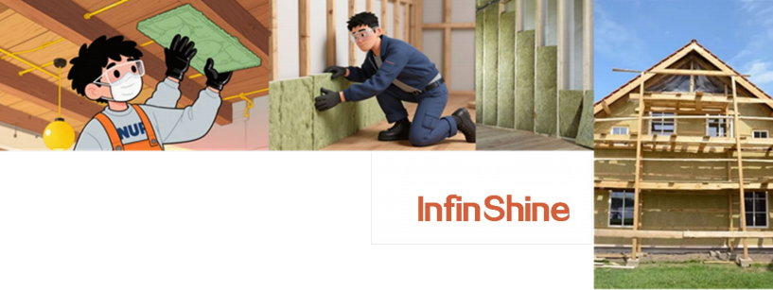

InfinshineTM Mineral Wool SF16 & SF24

Soundproofing and Fire Insulation

Description
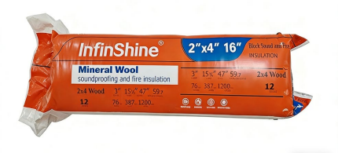
Mineral Wool SF16 & SF24 are a
premium semi-rigid stone wool batt
insulation for exterior wood/steel stud assemblies in new builds and
renovations. Its innovative flexible
edges compress during installation,
then spring back to seal studs and fill
wall cavities fully—ensuring easy fitting and consistent rated R-value.
Non-combustible with strong fire resistance, it retains integrity under direct flame, emits no toxic smoke, and stops flame spread (meeting strict fire standards). It also resists water/moisture (preventing mold) and offers excellent sound absorbency for better indoor acoustics.
A high-performance choice for home energy efficiency, it cuts wall heat transfer to lower HVAC loads. GREENGUARD and ULC certified, it supports healthier, safer interiors.

Features & Benefits
Non-combustible & Fire-resistant: Mineral Wool SF16 & SF24 generate no smoke and suppresses flame spread when exposed to fire.
Effortless Installation: Featuring a proprietary flexible-edge design, simply insert SF Mineral Wool batt into the stud cavity, compress, and release for a secure fit.
Superior Noise Reduction & Sound Absorption: Effectively mitigates noise and absorbs sound, helping create quieter, more productive environments.
Water & Moisture Resistant: Mineral Wool inhibits mold growth, ensuring long-term performance in humid conditions.

Uses
u Engineered specifically for framed exterior wall cavities.
u Precision-sized for compatibility with both wood and steel stud construction.
u Versatile application suitable for attic floors and cathedral ceilings.
u Optimal solution for basement renovation projects.

Technical Data

Item | Performance |  |  |  |  |  |  | Test  Standard
Reaction to  Fire | Flame spread rating (FSR)=15,  Smoke developed classification (SDC)=5  Class A |  |  |  |  |  |  | CAN/ULC S  102
Reaction to  Fire |  |  |  |  |  |  |  | GB/T 8624
Density | ≥1.94lbs/ft3 (≥30kg/m3) |  |  |  |  |  |  | ASTM C167
Corrosion  Resistance | Corrosiveness to Steel-Passed |  |  |  |  |  |  | ASTM C665  GB/T 11835
Reaction to  Moisture | Mass Moisture Absorption Rate (50℃,95% RH, 96H) ≤0.5%  Hydrophobicity Rate ≥98% |  |  |  |  |  |  | GBT 5480
Reaction to  Moisture |  |  |  |  |  |  |  | GBT10299
Asbestos  Phase | Asbestos-Free |  |  |  |  |  |  | HJ/T206
Dimension | 47" x 15.25" x 3" (1194mm X 387mm X 76mm),12pcs/bag 47" x 23" x 3" (1194mm X 584mm X 76mm), 8pcs/bag
Acoustical  Performance | Thickness  (In.) 3 | 125Hz  0.19 | 250Hz  0.83 | 500Hz  1.2 | 1000Hz  1.14 | 2000Hz  1.04 | 4000Hz  1.09 | NRC  ASTM C423  1.05

Certifications and Sustainable Features


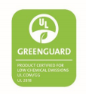


Shanghai Infinshine New Material Technology Co., Ltd.
Room 108, Building 1, No. 5158 Jinshan Avenue, Jinshan District, Shanghai, China
Postal Code: 201500

